First java code in VSCode IDE
Java Project
How to create Java project: https://www.youtube.com/watch?v=tYYVeCB7Ef4

Advantages of working with project structure
- Use this when your program needs multiple files working together.
- It keeps your source code (src) separate from your compiled code (bin).
- It allows you to organize your files into packages (folders) as your code grows.

Step-by-Step Setup
To create a Java project in VS Code, use the built-in Java project wizard.
- Open Command Palette: Press Ctrl + Shift + P (or Cmd + Shift + P on Mac).
- Launch Wizard: Type Java: Create Java Project and select it from the list.
- Select Project Type: Choose No build tools for a simple project (or select Maven/Gradle for advanced projects).
- Choose Location: Select the folder where you want to save your project files.
- Name Project: Input a name for your project folder and press Enter.

What Gets Created
VS Code automatically generates a standard folder structure for you.
- src/: The folder where you will write all your .java source code files.
- lib/: The folder to drop external libraries or .jar dependencies.
- App.java: A starter file containing a default "Hello, World!" program.
How to Run Your Project
- One-Click Run: Open App.java and click the Run button that appears directly above the main method.
- Shortcut: Press F5 on your keyboard to compile and debug the active file instantly
Standalone java File
How to create standalone Java in VSCode:
https://code.visualstudio.com/docs/java/java-tutorial#_creating-a-source-code-file
- Use this when you want to write a quick loop or test a piece of logic.
- You do not need any special configuration or folders.
- You cannot easily link it to other Java files.
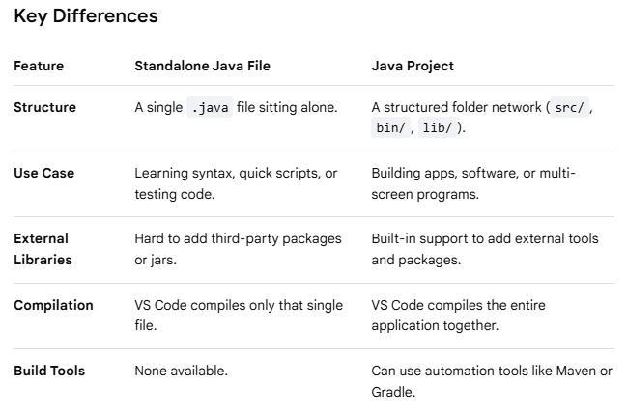

Understand starting point of Java program
public class Main {
public static void main(String[] args) {
System.out.println("Hello, World!");
}
}
Breakdown of the Code
- public class Main: Creates a container for your code. The class name must match your file name (e.g., Main.java).
- public static void main: The starting point (entry gate) where Java begins executing your program.
- System.out.println(): The built-in command used to print text out to the screen

The public static void main(String[] args) line is the exact entry point for every Java application. When you run a Java program, the Java Virtual Machine (JVM) looks specifically for this exact sequence of words to start executing your code. If any part of it is missing or misspelled, your program will not start.

Compile the code: Type javac Main.java and press Enter to convert your code into machine-readable bytecode.
Execute the program: Type java Main and press Enter to see your message print to the console.
Or
Run from VSCode

